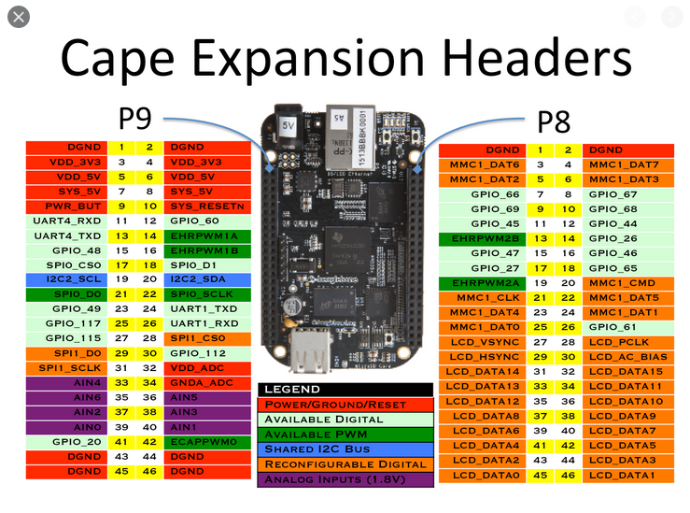
PWM9_14
GPIO9_18
GPIO9_24

PWM9_22
GPIO9_26
GPIO9_30

P8_17 standby

